**Tech Saksham**

**Data Analysis with Power BI**

**360- DEGREE BUSINESS ANALYSIS OF ONLINE DELIVERY APP**

***Nanjil Catholic College of Arts & Science, Kaliyakkavilai***

|  |  |
| --- | --- |
| NM ID | Name |
| **C9F53728A3E2B39B3B541A4AB554CE1F** | **ARIYA M U** |

Trainer Name: R Uma Maheshwari

Master trainer: Uma Maheshwari

ABSTRACT

The proposed project, 360-Degree Business Analysis Of Online Delivery. The volume of data keeps rising and data technologies change every other day . This make it more difficult for the organizations to benefit from data driven strategy across the organization. Data visualization with power BI enables anyone to collect, prepare, analyse, and visualize data in minutes and help make better business decisions. Dashboards are an important visualization format that provides 360-degree-view and helps quickly gain insights.

INDEX

|  |  |  |
| --- | --- | --- |
| Sr.No | Table of contents | Page No |
| 1 | Chapter 1: Introduction | 1 |
| 2 | Chapter 2: Services and Tools Required | 4 |
| 3 | Chapter 3: Project Architecture | 5 |
| 4 | Chapter 4: Modelling and Result | 7 |
| 5 | Conclusion | 9 |
| 6 | Future Scope | 9 |

CHAPTER 1

INTRODUCTION

1.1 Problem Statement :

360 Degree feedback fosters open communication and builds trust within teams. By understanding how colleagues perceive each others strengths and weaknesses teams can address interpersonal challenges improve collaboration and build a more cohesive working environment.

1.2 Proposed Solution :

Customer 360, or single customer view, delivered through a CRM or MDM application for effective customer engagement, operational processing, frictionless omnichannel experience based on trusted, high quality data.

Customer loyality is key for a business and to achieve it organisations require a comprehensive understanding of how their customers engage with them. Building an accurate 360 – degree customer view, including their buying behaviours, channels preferences and purchasing history, is a complicated undertaking, particularly when operating globally.

1.3 Feature:

Value Creation: core competencies key resources governance complementary assests value networks.

Value Proposition: * Product offering

*Service offering

*Pricing model

Value Delivery: Distribution channels target markrt segments.

Value Capture: Revenue model cost structure profit allocation.

1.4 Advantages:

*Increase self-Awareness

*Offers Objective Evaluation

*Reduces Workspace Bias

*Improve Work Relationships

*Create Open Culture

1.5 Scope:

A 360-degree view provides a complete, holistic view of a business entity. Moat commonly, organizations focus on 360- degree views of a customer. But a 360- degree views can also be products, locations, assests, employees, or projects.Customer view is essentially a collection of intrinsic customer sata – usually in a master data management system. Typical master data includes a legal name and address, parent and ultimate parent induatrial classification and account contacts.

CHAPTER 2

SERVICES AND TOOLS REQUIRED

2.1 Services Used:

Hard data:

This type of data gives you fact about your customers and comes from online accounts and transactions among other sources. Hard data also includes customers interactions with your business such as chats and emails.

Soft data:

Hard data can tell you plenty about what your customers are doing, but you need soft data to understand how they’re feeling. Soft data is often hidden within the hard data, and it’s invaluable in helping you understand the people behind the information for a full 360- degree view.

2.2 Tools and Software used:

There are multiple excellent options for creating data visualizations as well. Microsoft’s Visio is perhaps the most popular with Business Analysts, but Data Analysts might also recommend *Tableau

*PowerBI

*Bokeh

*Plotly

*Infogram

360 degree software is a valuable tool used by organizations to gather comprehensive feedback on an individual’s performance from multiple prespectives, including peers, managers, subordinates and sometimes even external stakeholders.

Data visualisation tools descriptive and predictive analystics software, data mining tools and statistical analysis software are all utilised in business analytics.

CHAPTER 3

PROJECT ARCHITECTURE

3.1 Architecture

User services

Payment services

Order services

Tracking services

ui

Restaurant Owners

Admin

Customers

Delivery partners

Tracking Engine

API

Data Architecture principles are a set of policies that govern the enterprise data framework with its operating rules for collecting integrating using and managing data assets. The basic purpose of the Data Architecture principles is to keep the supportive data framework clean consistent and auditable. The overall enterprise Data Strategy is built around these principles

1. Data Collection: Real-time customer data is collected from various sources like

bank transactions, customer interactions, etc. This could be achieved using

services like Azure Event Hubs or AWS Kinesis.

2. Data Storage: The collected data is stored in a database for processing. Azure

SQL Database or AWS RDS can be used for this purpose.

3. Data Processing: The stored data is processed in real-time using services like

Azure Stream Analytics or AWS Kinesis Data Analytics.

4. Machine Learning: Predictive models are built based on processed data using

Azure Machine Learning or AWS SageMaker. These models can help in

predicting customer behavior, detecting fraud, etc.

5. Data Visualization: The processed data and the results from the predictive

models are visualized in real-time using PowerBI. PowerBI allows you to create

interactive dashboards that can provide valuable insights into the data.

6. Data Access: The dashboards created in PowerBI can be accessed through

PowerBI Desktop, PowerBI Service (online), and PowerBI Mobile.

CHAPTER 4

MODELING AND RESULT

MANAGE RELATION SHIP

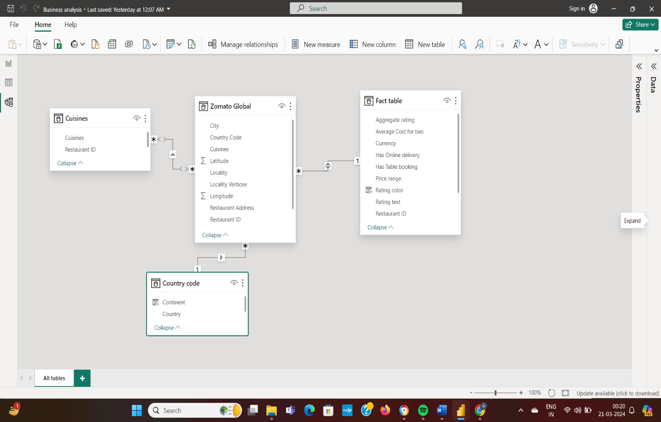

The country code, fact table , Zomato global, ciusines are interconnected therby forming a relation that gives a clear idea about the relation of these datas

DATAS

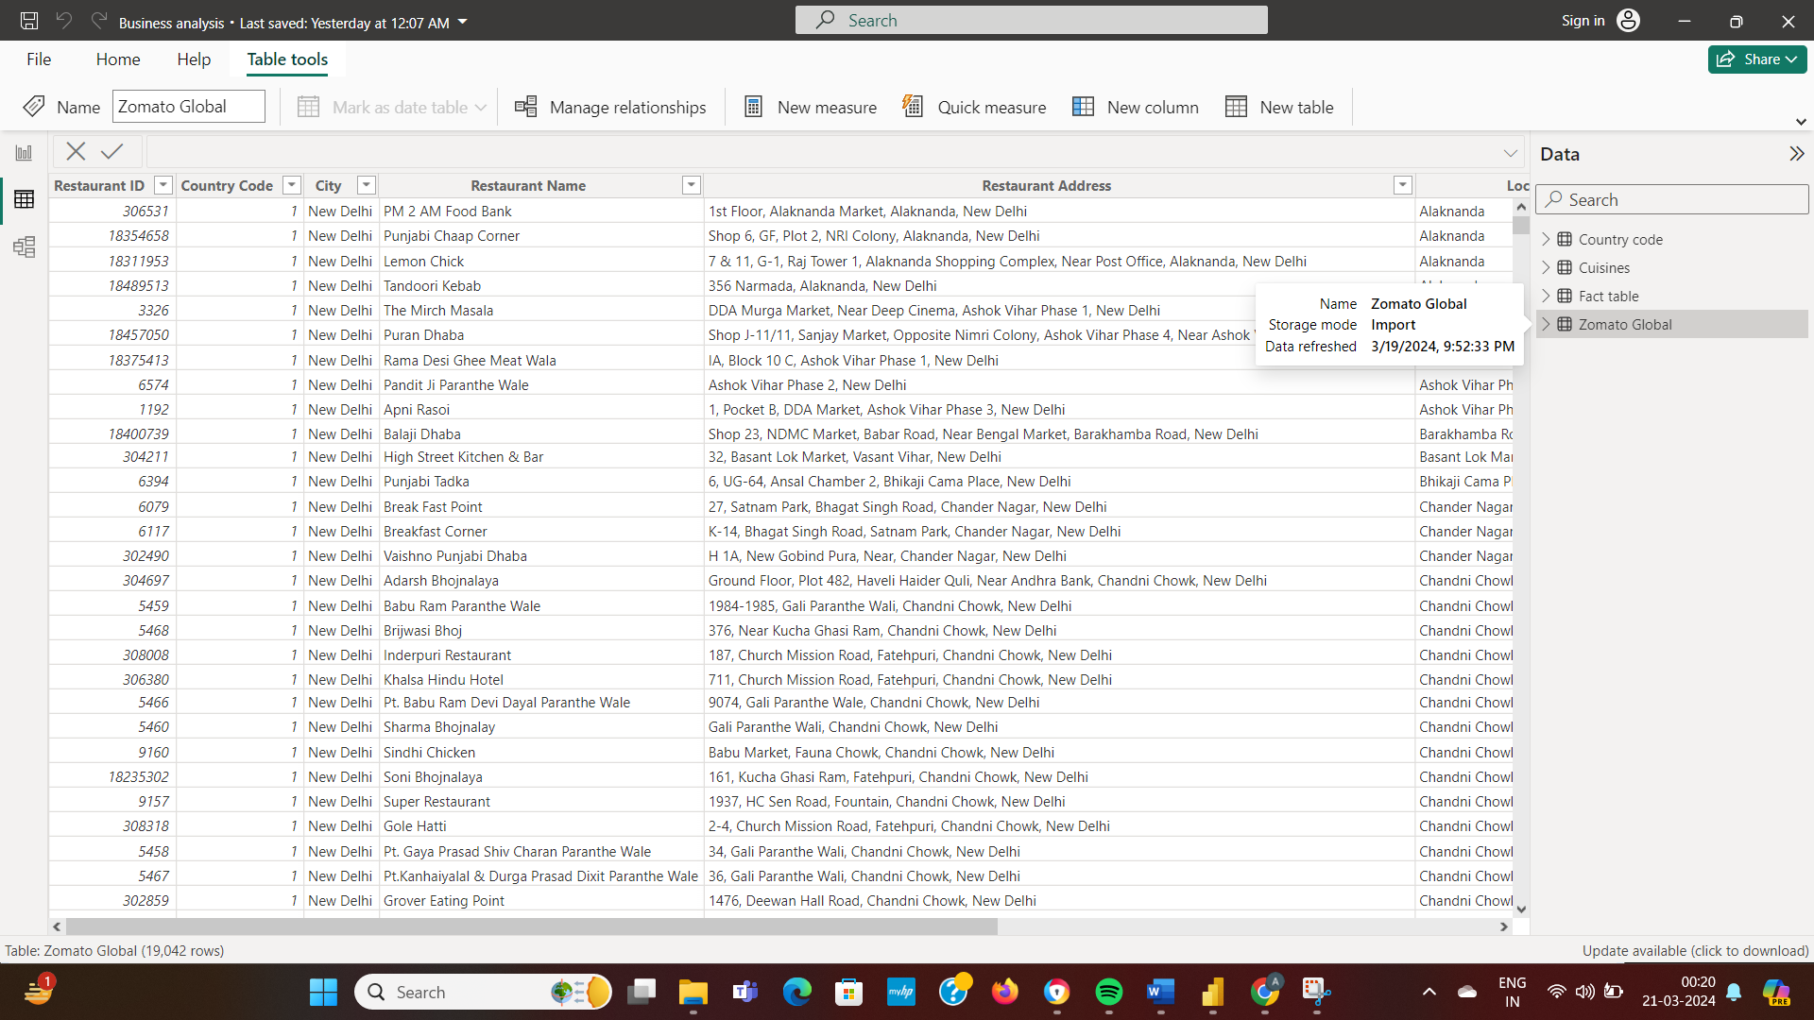

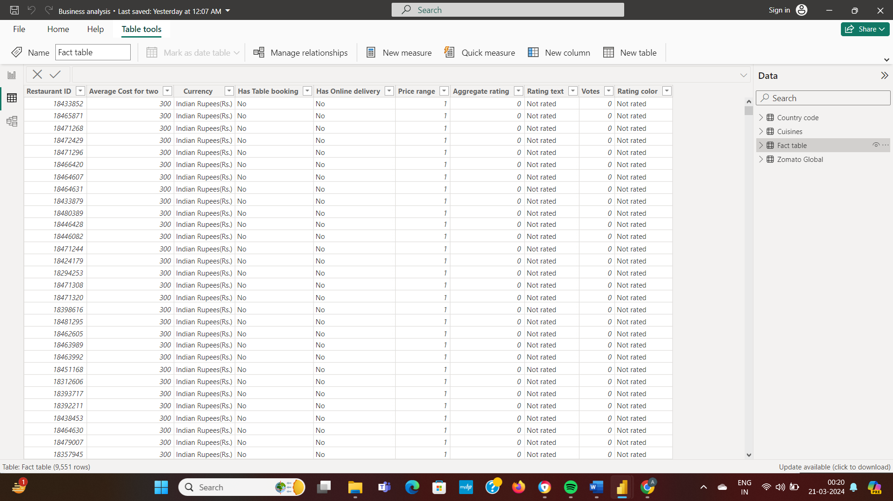

DASH BOARD

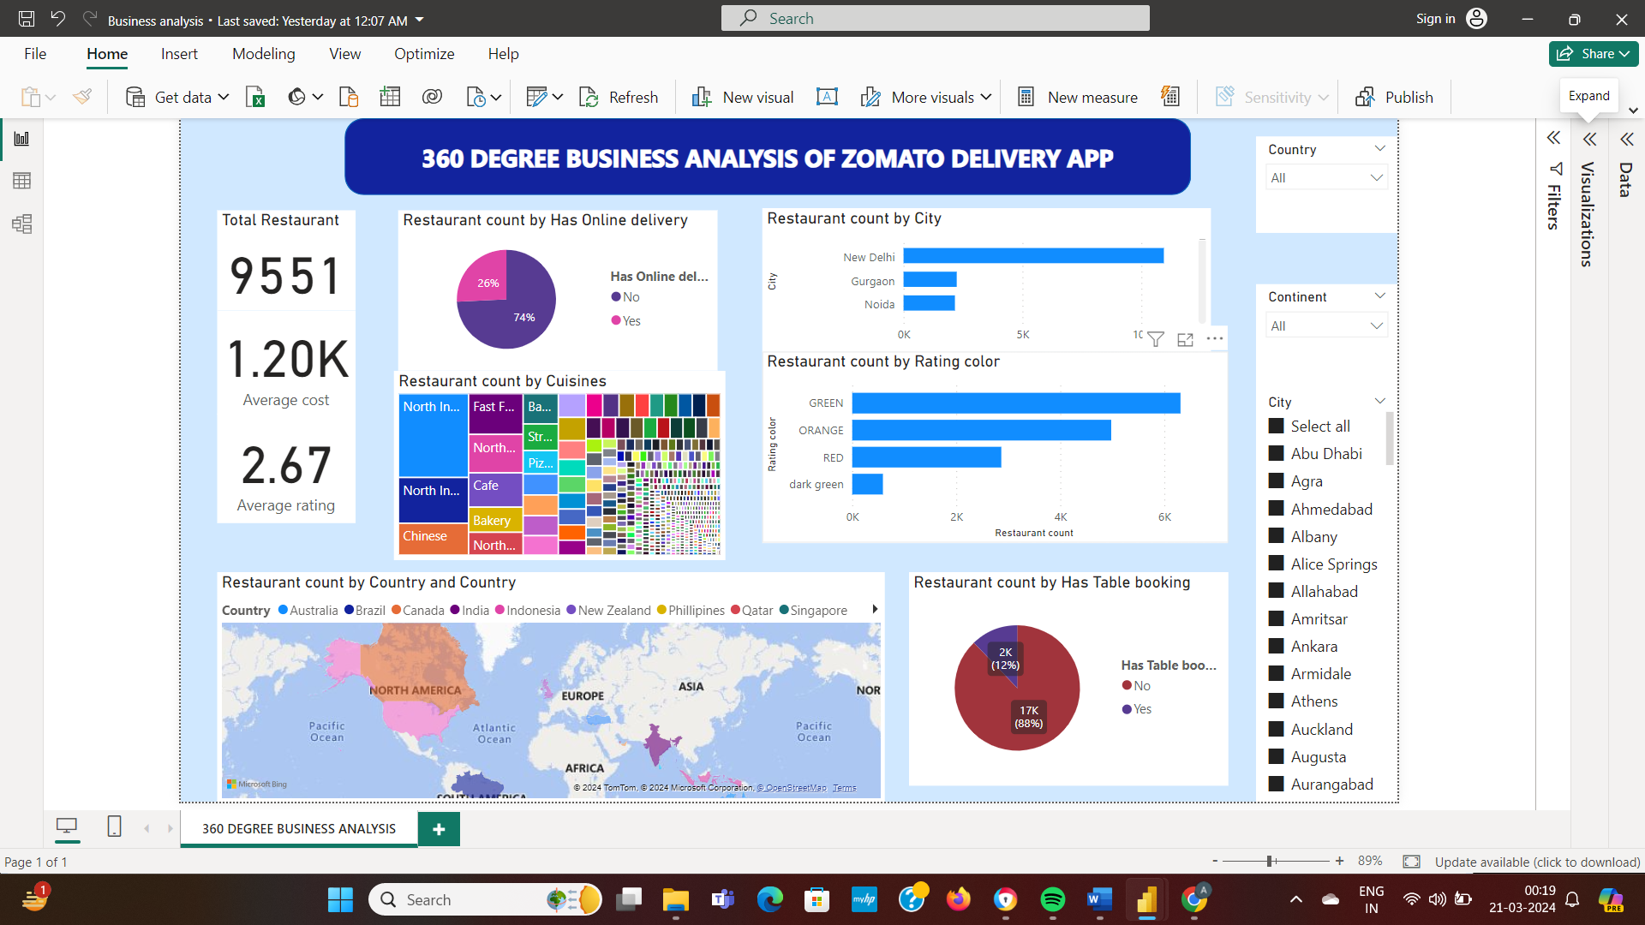

© Edunet Foundation. All rights reserved |19

CONCLUSION

Running a company requires constant decision-making. The company's leader lacks the necessary control over a decision and does it as best as they can, or even by mistake.

The benefits of Power BI are numerous, and it aids management teams in making fast decisions without jeopardizing the company's profitability. Data visualization is made simple with Power BI. It has a full summary of company data in visual form, with display choices such as tables, charts, gauges, and maps. This makes it easier for teams to use.

Power BI helps companies be more efficient, agile, and flexible by making it easy to see results. Power BI is a powerful business intelligence and data visualization tool developed by Microsoft. It offers a range of benefits that make it popular for data analysis and reporting:

Through 360 degree business analysis of Zomato app we can analyse datas through create compelling visualizations, charts, graphs, and dashboards from your data. These visuals are interactive and provide insights that are easy to understand, making it simpler to communicate complex information.

FUTURE SCOPE

The future scope of this project is vast. With the advent of advanced analytics andmachine learning, PowerBI can be leveraged to predict future trends based onhistorical data. Integrating these predictive analytics into the project could enable thebank to anticipate customer needs and proactively offer solutions. Furthermore,PowerBI’s capability to integrate with various data sources opens up the possibility ofincorporating more diverse datasets for a more holistic view of customers. As dataprivacy and security become increasingly important, future iterations of this projectshould focus on implementing robust data governance strategies. This would ensurethe secure handling of sensitive customer data while complying with data protectionregulations. Additionally, the project could explore the integration of real-time datastreams to provide even more timely and relevant insights. This could potentiallytransform the way banks interact with their customers, leading to improved customer satisfaction and loyality